 

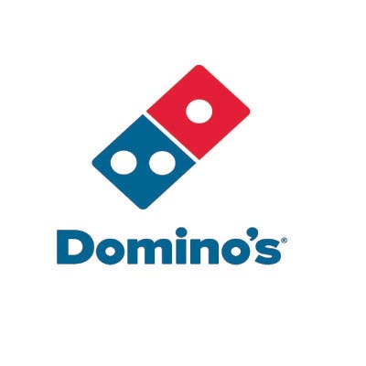[Domino’s Ratings Analysis]

-Mohit Kumar

**[ This Document is reflecting the idea used for analysis for the capstone project to be Submitted on Coursera.]**

[**Business Idea**]

* Today, Rating plays an important part in decision making where people have to choose between different options. Whether selecting a movie, shopping any gadget/items online, dinning out or even ordering food online, we go through various options and we most probably choose the option having the highest ratings.
* So, maintaining a good rating is one of the success keys in this competitive market, in this Analysis we are going to Study the ratings of all the domino’s outlets and comparing it with other nearby competitors like Pizza Hut, Little Caesar's Pizza, etc.
* Dominos can have a scheme or an award system where Outlets maintaining the good ratings will be awarded with yearly bonus and also it will highlight the outlets having the low ratings, such outlets be asked to look up on the reason of having bad ratings & asked to improve their services.
* ***The idea of the study is to help dominos to assess and maintain the ratings so to sustain in this competitive market and rule the people choice by providing the best services***